Stellar Distress Beacon Triage
Deep in the Andromeda corridor, an autonomous relay station named HELIOS-9 listens for distress beacons broadcast by stranded spacecraft. Beacons arrive at unpredictable times, and each carries a Severity reading on the station's criticality scale.
On this scale, a SMALLER number means a MORE critical emergency:
- A Severity of 1 is a hull breach with seconds to spare.
- A large value is a minor sensor glitch that can wait.
HELIOS-9 has a single rescue dispatcher. Whenever the dispatcher is free and decides to act, it must always respond to the single most critical beacon currently active, the one with the smallest Severity. The station also lets operators peek at the most critical beacon without dispatching, and it keeps running until it receives a shutdown signal.
Your job is to implement the brain of HELIOS-9. You must process a stream of commands, one per line, until the command END is reached. Maintain a collection of active beacons that supports inserting a beacon and repeatedly removing the most critical one efficiently. This is exactly the behaviour of a binary min-heap (priority queue), and you are expected to implement it as such.
Each beacon has a unique integer ID and an integer Severity. "Most critical" is defined as the smallest Severity. If two beacons share the same Severity, the beacon with the smaller ID is considered more critical (tie-break by ID).

Commands
Each line contains exactly one command in one of the forms listed below:
- BEACON <ID> <Severity> : A new distress beacon arrives; insert it into the active set. A BEACON command is followed by two integers: the ID and the Severity, separated by a single space.
- TRIAGE : The dispatcher handles (removes) the single most critical active beacon and reports it. If there are no active beacons, it reports that the station is idle.
- PEEK : Report the current most critical beacon WITHOUT removing it. If there are no active beacons, report idle.
- END : Stop reading commands and print a final shutdown summary. The command sequence is always terminated by a line containing END (END is guaranteed to appear).

Input Format
- Each line contains exactly one command in one of the forms listed above.
- A BEACON command is followed by two integers: the ID and the Severity, separated by a single space.
- The command sequence is always terminated by a line containing END (END is guaranteed to appear).
- All beacon IDs that appear in the input are distinct.

Output Format
Produce one line of output for every TRIAGE and PEEK command, in the order they are processed, plus one final summary line:
- TRIAGE with at least one active beacon:
[HANDLE] Beacon <ID> dispatched (Severity: <Severity>).
- TRIAGE with no active beacon:
[IDLE] No active beacons.
- PEEK with at least one active beacon:
[CRITICAL] Beacon <ID> (Severity: <Severity>).
- PEEK with no active beacon:
[IDLE] No active beacons.
- After END (always the last line of output):
[SHUTDOWN] Remaining beacons: <count>.
where <count> is the number of beacons still active.
Note: the BEACON and END commands themselves produce no output (other than END's final summary line).
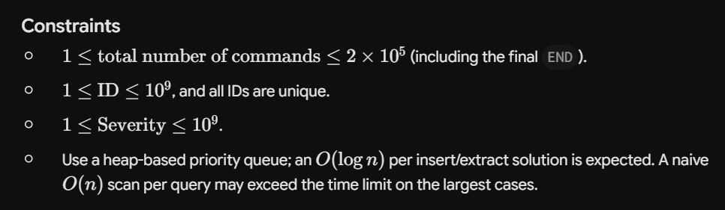

Sample Case 1
Input (standard input)
Plaintext
BEACON 101 5
BEACON 102 2
BEACON 103 8
PEEK
TRIAGE
TRIAGE
BEACON 104 1
TRIAGE
END

Output (standard output)
Plaintext
[CRITICAL] Beacon 102 (Severity: 2).
[HANDLE] Beacon 102 dispatched (Severity: 2).
[HANDLE] Beacon 101 dispatched (Severity: 5).
[HANDLE] Beacon 104 dispatched (Severity: 1).
[SHUTDOWN] Remaining beacons: 1.

Explanation: Beacons 101 (sev 5), 102 (sev 2), 103 (sev 8) are inserted. The most critical is 102 (smallest severity), so PEEK reports beacon 102. First TRIAGE removes and dispatches 102 (sev 2). Active now: 101 (sev 5), 103 (sev 8). Second TRIAGE dispatches 101 (sev 5), the new minimum. Active now: 103 (sev 8). Beacon 104 (sev 1) arrives, now the most critical. The third TRIAGE dispatches 104 (sev 1). At END, only beacon 103 remains, so the summary reports 1 remaining beacon.

Sample Case 2
Input (standard input)
Plaintext
TRIAGE
PEEK
BEACON 7 50
BEACON 3 50
TRIAGE
TRIAGE
TRIAGE
END

Output (standard output)
Plaintext
[IDLE] No active beacons.
[IDLE] No active beacons.
[HANDLE] Beacon 3 dispatched (Severity: 50).
[HANDLE] Beacon 7 dispatched (Severity: 50).
[IDLE] No active beacons.
[SHUTDOWN] Remaining beacons: 0.

Explanation: The first TRIAGE and PEEK occur while the station is empty, so both print the idle message. Beacons 7 and 3 arrive, both with Severity 50. Because the severities tie, the smaller ID wins: beacon 3 is more critical. The next TRIAGE dispatches beacon 3, then the following TRIAGE dispatches beacon 7. The third TRIAGE finds the station empty again and prints the idle message. At END, no beacons remain, so the count is 0.

